**Introduction to Database**

Problem Statement: There can be multiple customers, who can place multiple orders on the site. Now a sales person can handle these orders will distribute into multiple sales persons (One order will be assign to one salesperson only). So a sales person can have multiple orders of multiple customers

Create Database

Design Schema

Create tables

Insert sample data

Find the sales person have multiple orders.

Find the all sales person details along with order details

Create index

How to show index on a table

Find the order number, sale person name, along with the customer to whom that order belongs to

Create Database:

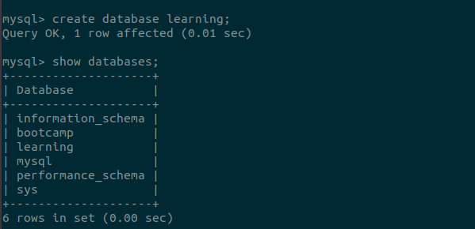

Design Schema

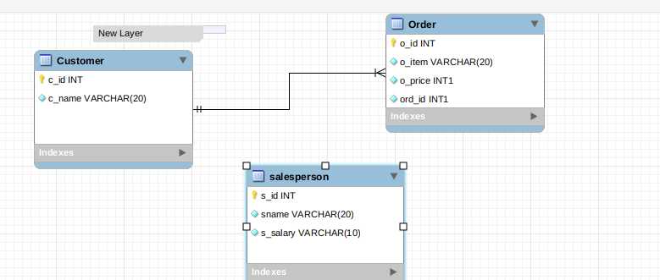

**Create Table**

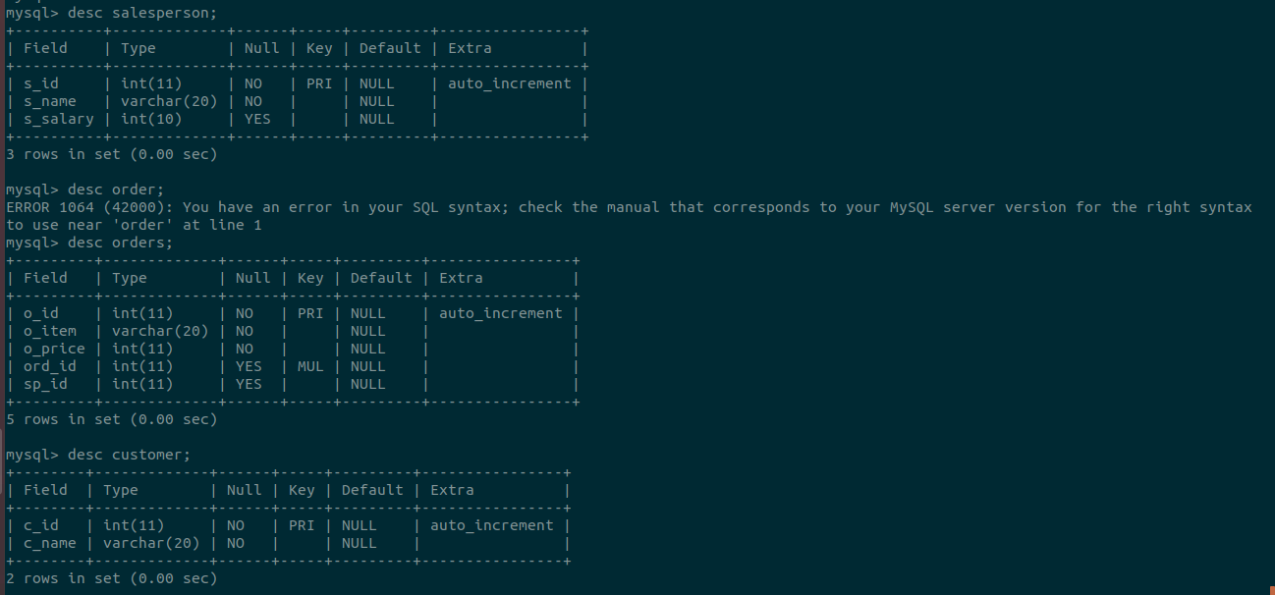

**Insert Sample Data**

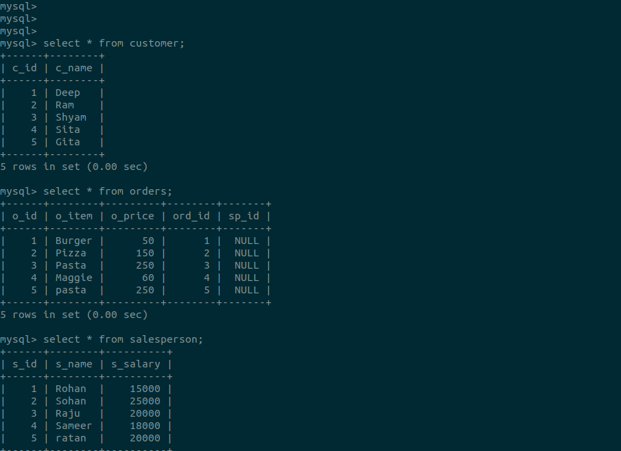

**Find the sales person have multiple orders.**

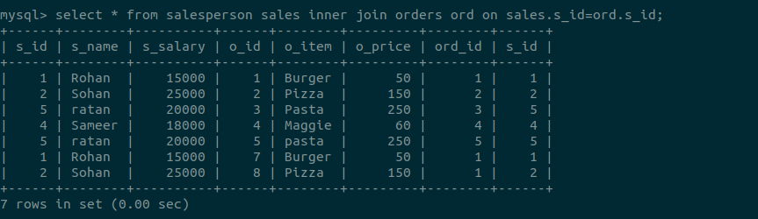

**Find the all sales person details along with order details**

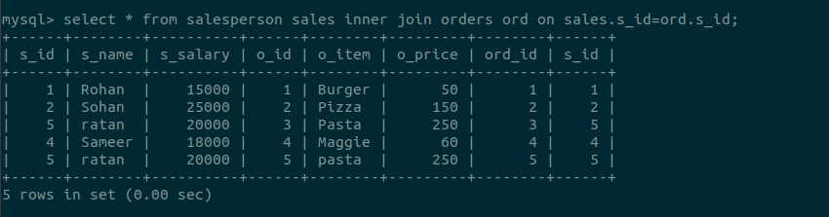

**Create Index**

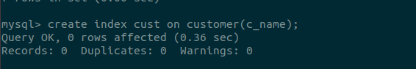

**How to show index on a table**

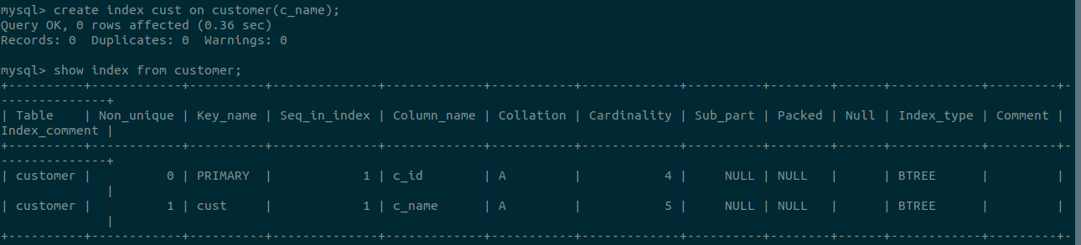

**Find the order number, sale person name, along with the customer to whom that order belongs to**